**ART 132**

**Assignment 2**

**Value Scales**

**Value** deﬁnes how light or dark a given color or hue can be. Values are best understood when visualized as a scale or gradient, from dark to light. The more tonal variants in an image, the lower the contrast. When shades of similar value are used together, they also create a low contrast image.

**Contrast** refers to the arrangement of opposite elements (light vs. dark colors, rough vs. smooth textures, large vs. small shapes, etc.)

Utilizing contrast is a great way to create an interesting composition.

**In this ﬁrst exercise you will create a series of value scales on bristol paper.** Your bristol paper pack should be at least 9x12” large.

Step 1

Using your cork backed ruler on your bristol paper, carefully measure out 5 rectangles that are 2x8.”

Step 2

Create evenly paced value scales (going from dark to light) using the following techniques.

1. Smooth gradation using graphite (pencil, non mechanical)
2. Hatching using black pen
3. Cross hatching using black pen
4. Creative method of your choosing using ink
5. Creative method of your choosing using ink

You will be assessed on how you follow directions, how smooth and evenly paced your value scales are as well as craft and attention to detail.

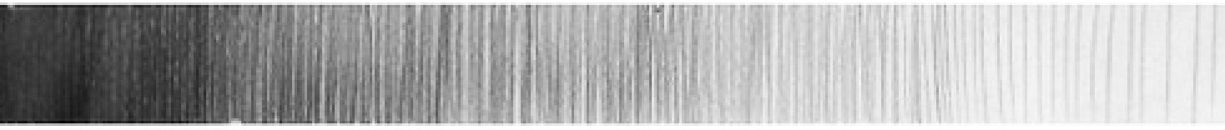Hatching

Cross Hatching

Stipple

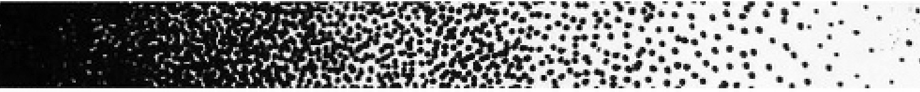

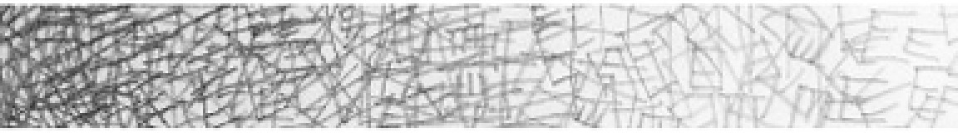Random Mark

